**Assessment 2 Task 2**

**Name** **:** Kishan Agarwal

**REG. NO** **:** 24BCT0208

**COURSE** **:** Web Programming

**SLOT** **:** L35 + L36 + L45 + L46

**FACULTY** **:** Dr. Sathya K

***SOURCE FILES:***

• index.html :

<!DOCTYPE html>

<html lang="en">

<head>

<meta charset="UTF-8">

<meta name="viewport" content="width=device-width, initial-scale=1.0">

<title>Kishan Agarwal - Portfolio Website</title>

<style>

body {

background-color: #f7ffab;

margin: 0;

font-family: Arial;

}

.heading {

text-align: center;

font-family: 'Courier New';

margin: 15px 0;

}

#banner-image {

height: 200px;

border-radius: 10px;

}

.ban-image {

text-align: center;

margin-bottom: 10px;

}

.headline {

text-align: center;

margin-bottom: 20px;

}

#about-me {

background-image: linear-gradient(rgba(0, 0, 0, 0.6), rgba(0, 0, 0, 0.6)), url("Images/iStock-1487972668-scaled.jpg");

background-size: cover;

background-position: center;

padding: 30px;

color: #ffe2e2;

}

.img-1,

.img-2 {

height: 180px;

border-radius: 10px;

}

.img-1 {

float: left;

margin-right: 20px;

margin-bottom: 10px;

}

.img-desc {

font-size: 17px;

color: #ffd28a;

}

nav {

padding: 20px;

}

</style>

</head>

<body>

<header>

<h2 class="heading">Portfolio Website</h2>

</header>

<main class="ban-image">

<img id="banner-image" src="Images/Kishan.png" alt="">

</main>

<h3 class="headline">Portfolio Page for Kishan Agarwal - 24BCT0208</h3>

<a href="#about-me">Go to about me section</a>

<a href="about.html">Go to full fleadge about section</a>

<nav>

<a href="https://dog-image-generater-kishan.netlify.app" target="_blank">Dog image fetcher using API Call</a>

<br><br>

<p>Project 2 - Click on the image to open deployed project</p>

<a href="https://random-color-generator-kishan.netlify.app/" target="_blank">

<img style="height: 150px;" src="Images/Screenshot 2026-01-10 at 6.37.44PM.png"

alt="This is a clickable image">

</a>

<br>

<a href="mailto:kishanagarwal1506@gmail.com">Mail me</a>

</nav>

<br><br><br>

<div id="about-me">

<p style="font-size: 28px;">I am Kishan Agarwal, studing in VIT Vellore. Currently studing Web Dev and DSA

mainly. Planning to complete

ML in future.</p>

<div>

<img class="img-1" src="Images/Kishan.png" alt="Image1">

<span class="img-desc">I was in Oragnizing Committee for Sense Hack Event.</span>

</div>

<br>

<div>

<img class="img-2" src="Images/Kishan2.jpeg" alt="Image1">

<span class="img-desc">I was speaker for the Event Hack The Hackathon organized during Gravitas'24</span>

</div>

<br><br><br>

<p style="font-size: 28px;">Hobbies and Interest:</p>

<div>

<img class="img-1" src="Images/cricket-equipment-digital-art_23-2151761214.avif" alt="Image1">

<span class="img-desc">I like Cricket.</span>

</div>

<br>

<div>

<img class="img-2" src="Images/book-pile-of-must-read-books-scaled1.jpg" alt="Image1">

<span class="img-desc">I like reading books.</span>

</div>

</div>

<footer>

<div class="contact">

<h2>Contact Me</h2>

<h3>Professional Contact Details</h3>

<p>

Email:

<a href="mailto:kishanagarwal1506@gmail.com">

kishanagarwal1506@gmail.com

</a>

</p>

<p>

GitHub:

<a href="https://github.com/KISHAN1506" target="_blank">

https://github.com/KISHAN1506

</a>

</p>

<p>

LinkedIn:

<a href="https://linkedin.com/in/kishan-agarwal15" target="_blank">

https://linkedin.com/in/kishan-agarwal15

</a>

</p>

<h3>Personal Contact</h3>

<p>

Phone Number: 6355XXXXXX

</p>

</div>

<div class="video-demonstration">

<video src="Images/0111.mov" height="450" controls></video>

</div>

</footer>

</body>

</html>

• about.html:

<!DOCTYPE html>

<html lang="en">

<head>

<meta charset="UTF-8">

<meta name="viewport" content="width=device-width, initial-scale=1.0">

<link rel="stylesheet" href="aboutcss.css">

<title>About Me</title>

</head>

<body>

<h2>About Me</h2>

<aside>

<a href="index.html">Go to Main Page</a>

</aside>

<div class="section">

<p class="intro">

I am Kishan Agarwal, currently studying at VIT Vellore.

I am learning Web Development and DSA, and planning to explore

Machine Learning in the future.

</p>

<img class="img-1" src="Images/Kishan.png" alt="My Photo">

<span class="img-desc">

I was part of the Organizing Committee for the Sense Hack event.

</span>

<div class="clear"></div>

<br>

<img class="img-2" src="Images/Kishan2.jpeg" alt="My Photo">

<span class="img-desc">

I was a speaker at the event “Hack The Hackathon” organized during Gravitas’24.

</span>

</div>

<h2>Hobbies and Interests</h2>

<div class="section">

<img class="img-1" src="Images/cricket-equipment-digital-art_23-2151761214.avif" alt="Cricket">

<span class="img-desc">

I enjoy playing and watching cricket in my free time.

</span>

<div class="clear"></div>

<br>

<img class="img-2" src="Images/book-pile-of-must-read-books-scaled1.jpg" alt="Books">

<span class="img-desc">

I like reading books to gain knowledge and improve my thinking.

</span>

</div>

</body>

</html>

• aboutcss.css :

body {

background-color: #f7ffab;

font-family: Arial, sans-serif;

margin: 0;

padding: 20px;

}

h2 {

text-align: center;

margin-bottom: 20px;

}

.section {

margin-bottom: 40px;

}

.intro {

font-size: 26px;

margin-bottom: 20px;

}

.img-1,

.img-2 {

height: 180px;

border-radius: 10px;

}

.img-1 {

float: left;

margin-right: 20px;

margin-bottom: 10px;

}

.img-desc {

font-size: 17px;

line-height: 1.5;

}

***OUTPUT:***

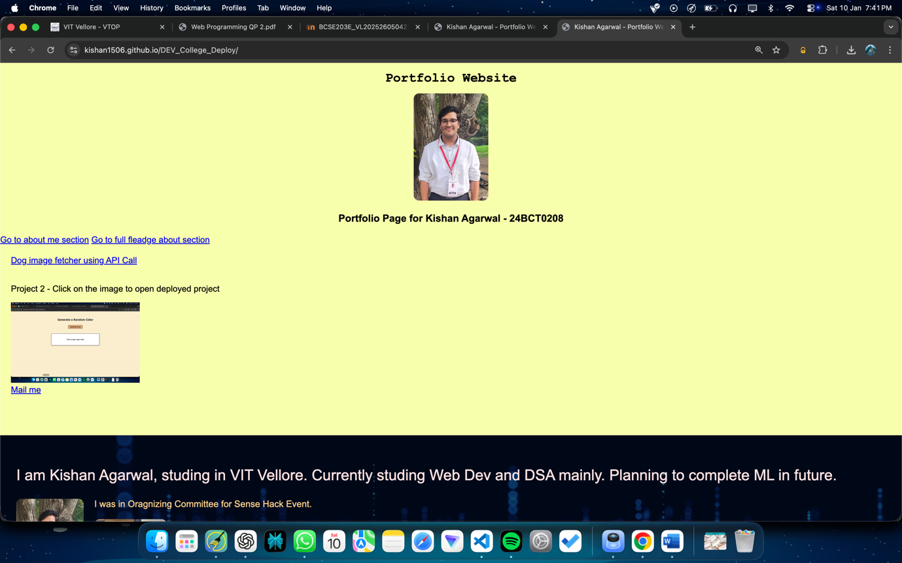

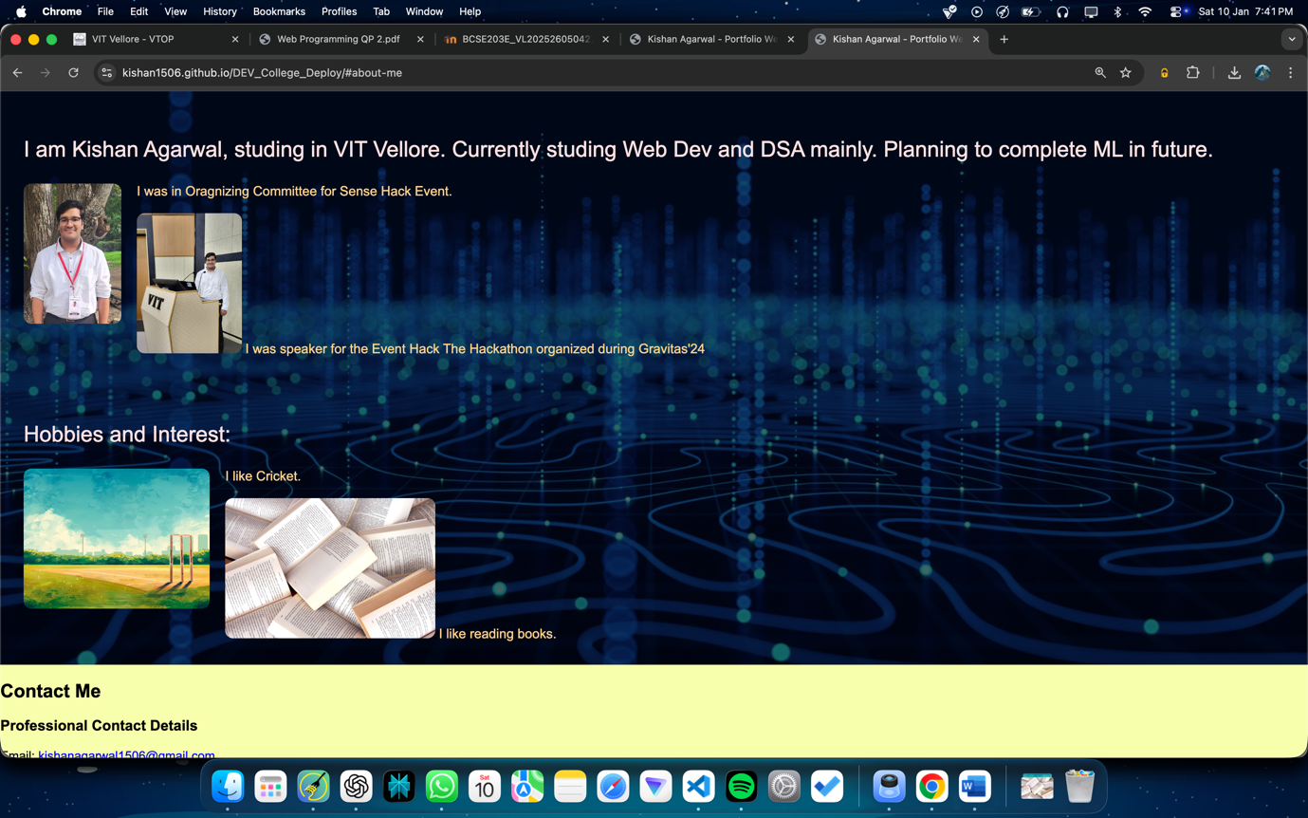

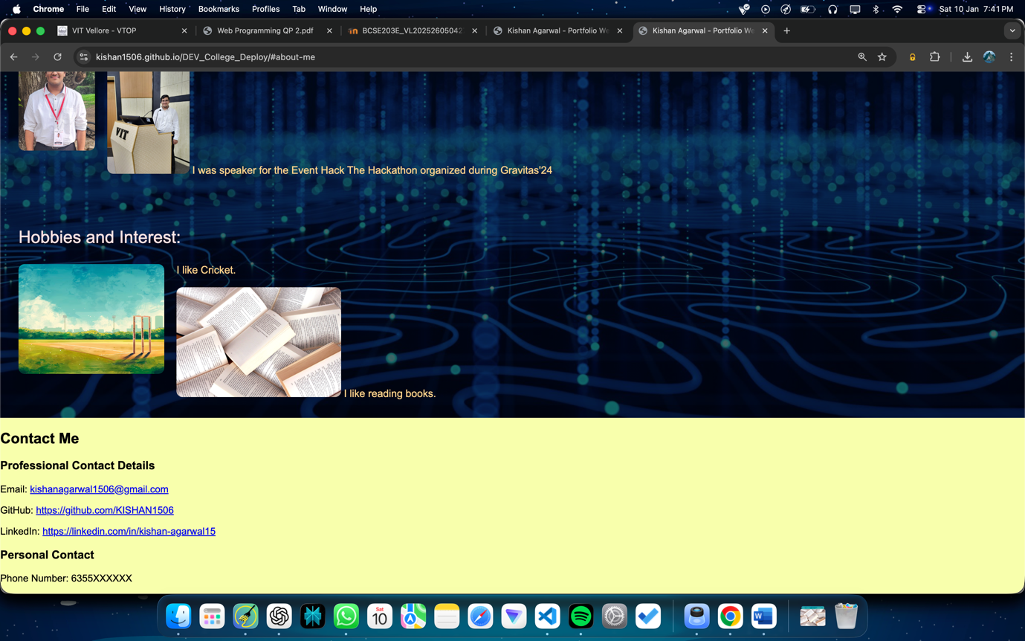

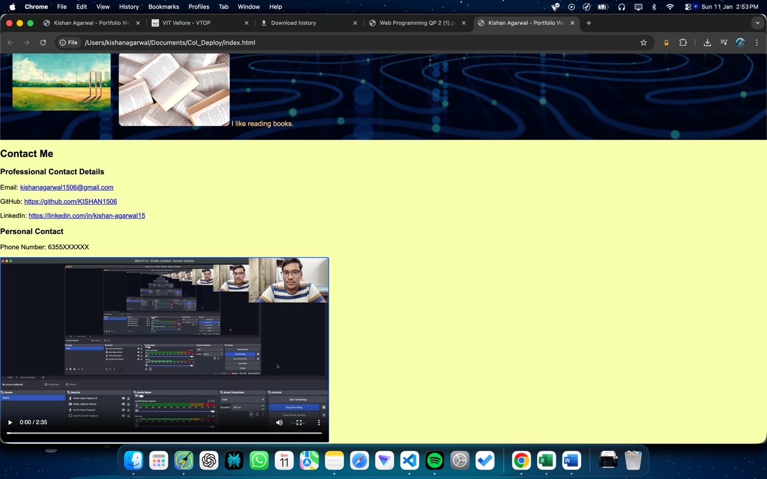

**ABOUT ME :**

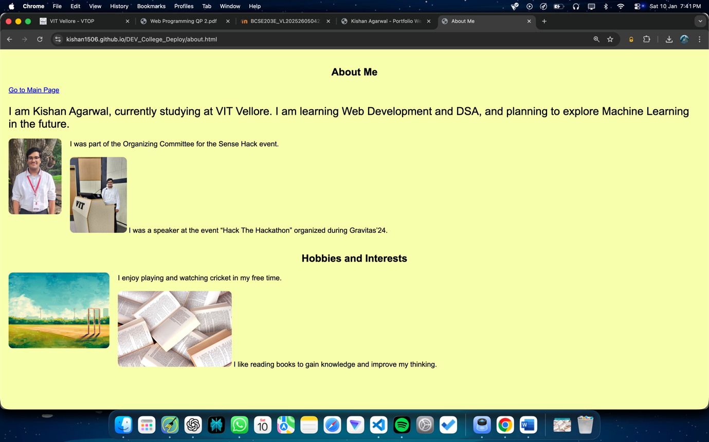

DEPLOYED LINK:

<https://kishan1506.github.io/Col_Deploy/>

Drive Link for Deployment Explanation:

<https://drive.google.com/file/d/14k7WsJudSTClJc9YL9uNydmjpPXiitXA/view?usp=sharing>